QUESTION 1
You are working on an Oracle Database 10g database. You enabled the Flashback Database feature. Which two statements regarding flashback logs are true? (Choose two.)

A. | Flashback logs are not archived.
B. | Flashback logs are maintained in redo log files.
C. | Flashback logs are maintained in the Flash Recovery Area.
D. | Flashback logs are used to maintain Flashback Database related errors.
E. | Flashback logs need to be cleared manually after you disable Flashback Database.

QUESTION 2
You executed the following query:
SELECT operation, undo_sql, table_name
FROM flashback_transaction_query;
Which statement is correct regarding the query output?

A. | It would return information regarding only the last committed transaction.
B. | It would return only the active transactions in all the undo segments in the database.
C. | It would return only the committed transactions in all the undo segments in the database.
D. | It would return both active and committed transactions in all the undo segments in the database.
E. | It would return information regarding the transactions that began and were committed in the last 30 minutes.

QUESTION 3
Consider the following configuration:
/devices/D1is a member of disk group dgroupA.
/devices/D2is a member of disk group dgroupA.
/devices/D3is a member of disk group dgroupA.
You plan to add a new disk, /devices/D4,to the disk group dgroupA.
You execute the following command:
SQL> ALTER DISKGROUP dgroupA ADD DISK '/devices/D*';

Actualtests.com - The Power of Knowing
1Z0-043

Which task would be accomplished by the command?

A. | The command adds the new disk, D4, to the disk group.
B. | The command would result in an error because the is no disk by the name "'/devices/D*'"
C. | The command will be ignored because disks starting with "D" are already members of the disk group.
D. | The command would result in an error because no wildcard characters can be used in the disk name.
E. | The command first detaches all the member disks starting with "D", and the reattaches them including the new disk.

QUESTION 4
You work as a database administrator at Certkiller .com. In your production database there is a job,
CALC_STAT, which has been scheduled to run every Friday at 5.00 p.m. CALC_STATupdates the optimizer statistics for the objects owned by the APPSschema. You want the task to be generic, thereby allowing users to modify the attributes of the task at run time without affecting the original task. Which component of Oracle Scheduler must you define to achieve this?

A. | Window
B. | Program
C. | Job class
D. | Window group

QUESTION 5
You observe that a database performance has degraded over a period of time. While investigating the reason, you find that the size of the database buffer cache is not large enough to cache all the needed data blocks.
Which advisory component would you refer to, in order to determine that required size of the database buffer cache?

A. | Memory Advisor
B. | Segment Advisor
C. | SQL Tuning Advisor
D. | SQL Access Advisor
E. | Automatic Database Diagnostic Monitor (ADDM)

QUESTION 6

Exhibit

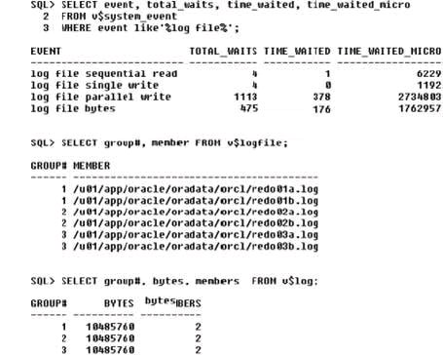

In your production database, the total waits and the time waited for log file parallel write are significantly high. While investigating the reason, you find that there are three redo log groups with two members in each group, and all redo log members are places on a single physical disk.
What action would you take to minimize the waits?

A. | start the log writer slave processes  Actualtests.com - The Power of Knowing  1Z0-043
B. | increase the number of redo log files
C. | increase the size of the redo log buffer
D. | place the redo log files on the different disks
E. | increase the number of log writer processes

QUESTION 7
One of the tablespaces is read-only in your database. The loss of all control files forced you to re-create the control file.
Which operation do you need to perform after re-creating the control file and opening the database?

A. | drop and re-create the read-only tablespaces
B. | rename the read-only data files to their correct file names
C. | change the tablespace status from read/write to read-only
D. | re-create the read-only tablespace because it is automatically removed

QUESTION 8
You have set some of the initialization parameters as:

DB_BLOCK_SIZE = 8KB

SGA_MAX_SIZE = 2GB
SGA_TARGET = 0
SHARED_POOL_SIZE = 120MB
DB_CACHE_SIZE = 896MB
STREAM_POOL_SIZE = 0
LARGE_POOL_SIZE = 110 MB
Which two statements are correct? (Choose two.)

A. | You cannot set a value for the DB_8K_CACHE_SIZE parameter.
B. | If you increase the size of the large pool to 120 MB, then the memory allocated to the shared poll will be reduced to 110 MB.
C. | If the value for SGA_TARGET is changed to 1 GB and SHARED_POOL_SIZE is set to 120 MB, then memory cannot be taken from the shared pool, even if the shared pool has free space available.
D. | If an application attempts to allocate more than 120 MB from the shared pool and free space is available in the buffer pool, then the free space from the buffer pool is allocated to the shared pool.

QUESTION 9
You are performing a block media recovery on the tools01.dbf data file in the SALESdatabase using RMAN. Which two statements are correct in this scenario? (Choose two.)

A. | You must ensure that the SALES database is mounted or open.
B. | You must restore a backup control file to perform a block media recovery.
C. | You must take the tools01.dbf data file offline before you start a block media recovery.
D. | You must put the database in NOARCHIVELOG mode to perform a block media recovery.
E. | You can perform only a complete media recovery of individual blocks, point-in-time recovery of individual data blocks is not supported.

QUESTION 10

Exhibit

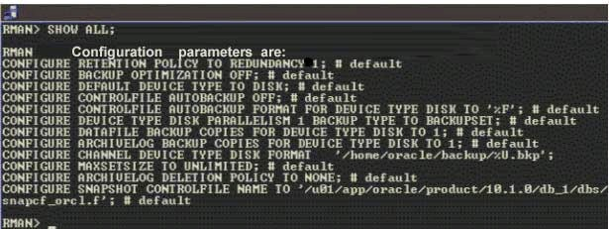

You executed the following command to perform a backup of the USERStablespace:

RMAN > BACKUP TABLESPACE USERS;

Which type of backup would this command perform?

A. | backup set
B. | image copy
C. | incremental backup
D. | None; the user receives an error indicating that the backup type must be specified.

QUESTION 11

In your database, online redo log files are multiplexed and one of the members in a

Actualtests.com - The Power of Knowing
1Z0-043

group is lost due to media failure?
How would you recover the lost redo log member?

A. | import the database from the last export
B. | restore all the members in the group from the last backup
C. | drop the lost member from the database and then add a new member to the group
D. | restore all the database files from the backup and then perform a complete recovery
E. | restore all the database files from the backup and then perform an incomplete recovery

QUESTION 12

You are using Oracle Database 10g. Which statement regarding an incomplete recovery is true?

A. | You do not need to restore all the data files.
B. | You do not need to open the database with the RESETLOGS operation
C. | You do not need to perform a full backup after the RESETLOGS operation.
D. | You do not need to recover all the data files to the same system change number (SCN).

QUESTION 13

Exhibit

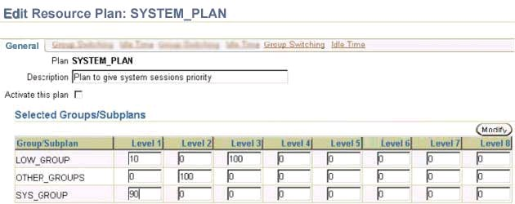

View the Exhibit and examine the Resource Manager settings for the groups at different levels.
Which two effects would be the result of this setting? (Choose two.)

A. | The members of LOW_GROUP would get more priority than those of OTHER_GROUPS.
B. | The members of SYS_GROUP would get most of the CPU allocation at level 1.
C. | The members of LOW_GROUP would get most of the CPU allocation because it has Actualtests.com - The Power of Knowing  1Z0-043  CPU allocation at two different levels.
D. | The members of LOW_GROUP would get no CPU allocation at level1 if the members of OTHER_GROUPS are using all the CPU at level 2.
E. | The members of SYS_GROUP would get no CPU allocation at level 1 if the members of OTHER_GROUPS are using all the CPU at level 2.

QUESTION 14
The current time zone for one of the user sessions is set to the database local time zone. For one application, the user session requires the time zone to be set to the local operating system time zone without affecting other user sessions. Which two solutions could the user implement to achieve this objective? (Choose two.)

A. | use the ALTER SYSTEM command to change the time zone
B. | use the ALTER SESSION command to change the time zone
C. | use the ALTER DATABASE command to change the time zone
D. | set the value for the operating system variable ORA_SDTZ on the client machine
E. | set the value for the operating system variable ORA_SDTZ on the database server machine

QUESTION 15
You work as a database administrator at Certkiller .com. Your database is open and running in ARCHIVELOGmode. You take RMANfull backups every Sunday night. On Monday morning, while querying the user1.employeestable, you receive the following error message:
01578: ORACLE data block corrupted (file # 5, block # 51) ORA-01110: data file 5:

'/u01/app/oracle/oradata/orcl/example01.dbf'
You need to rectify the corruption while ensuring the following:
The data file should remain online.
The mean time to recover (MTTR) should be minimal. You are not using a backup control file and all the archived logs are accessible.
Which option would you choose?

A. | flash back the corrupted blocks
B. | use the DBMS_REPAIR package
C. | use the RMAN TSPITR command
D. | use the RMAN BLOCKRECOVER command
E. | use the RESTORE DATABASE and RECOVER DATABASE commands Actualtests.com - The Power of Knowing  1Z0-043
F. | investigate the time at which the corruption occurred and perform a point-in-time recovery

